Upcoming Events:  June 29: Game Day at 1:00 Bring a small rock and Pat will teach us how to paint a rock. Pat will provide the paint.  Birthday: “God Bless You and Keep You Another Year Through”  Pat Wilkening June 28  Natalie Murphy July 4  Please join us for refreshments in our fellowship hall after the service.  If you wish to donate to the church, we now have the collection plate on the table by the entrance to the League Room. Or you can use our on-line giving option found on our website.  Contact Information:  Pastor Jinkyoung You  Email: holistic78@gmail.com  Phone number: 256-631-9906. Texting is best, if possible.  Email: brooklyncommunityumc@gmail.com  Facebook: Brooklyn Community UMC  Website: http://www.brooklynumc.org/ |  |  | 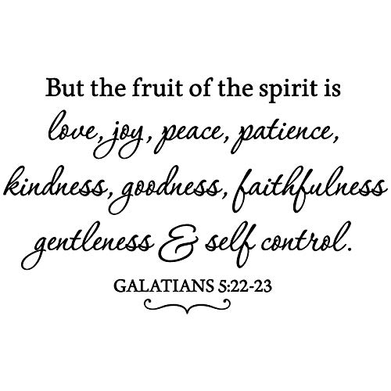  June 28, 2026  Brooklyn Community United Methodist Church  Pastor Jinkyoung You
Welcome to  Brooklyn Community United Methodist Church  June 28, 2026  Fifth Sunday after Pentecost  Minister: Pastor Jinkyoung You  Reader: Pat Wilkening  Pianist: Debbie Schneider  Percussionist: Dennis Murphy  Welcome & Greeting  Birthday, Anniversary, & Announcements  Prelude  Call To Worship: (Congregation reads the bold)  This is the day which God is creating  Let us rejoice and be glad in it!  Holy One, as this moment unfolds, your hand is in it.  We open our hearts to your presence. We open our souls to your Word. We listen and wait.  All: Alleluia! Come, Holy Spirit, and transform us by your grace. Alleluia!  Opening Prayer  *Hymn of Praise UMH #73  “O Worship the King”  Joys and Concerns |  |  | Pastoral Prayer/The Lord’s Prayer  *Hymn of Response UMH #428  “For the Healing of the Nation”  Scripture Reading Psalm 46: 1-3,10;  John 14:27 (CEB)  Congregation Response: Thanks be to God.  “You've Made Me So Very Happy” Dennis Murphy  Message “Fruit of the Spirit: Peace” Pastor Jinkyoung  *Offering/Doxology UMH #95  *Hymn of Affirmation UMH #377  “It Is Well with My Soul”  Benediction  Postlude  *Stand if you are able.  Please join us for refreshments in our fellowship hall after the service.  UMH United Methodist Hymnal  CEB Common English Bible

