Upcoming Events:  June 25: Community Potluck at noon; bring a dish to pass, table service and beverage provided  June 29: Game Day at 1:00  Birthday: “God Bless You and Keep You Another Year Through”  Cara Klitzman June 22  Cleo Tilley June 27  Edie Grossen June 27  Please join us for refreshments in our fellowship hall after the service.  If you wish to donate to the church, we now have the collection plate on the table by the entrance to the League Room. Or you can use our on-line giving option found on our website.  UMH United Methodist Hymnal  TFWS The Faith We Sing  CEB Common English Bible  Contact Information:  Pastor Jinkyoung You  Office Hours: Tuesday 9:00 a.m. – 2:00 p.m.  Thursday 1:30 – 4:00 p.m.  Email: holistic78@gmail.com  Phone number: 608-455-3344 M-Th 9-4. If you need to reach her at other times, please use her private number 256-631-9906. Texting is best if possible.  Email: brooklyncommunityumc@gmail.com  Facebook: Brooklyn Community UMC  Website: http://www.brooklynumc.org/ |  |  | 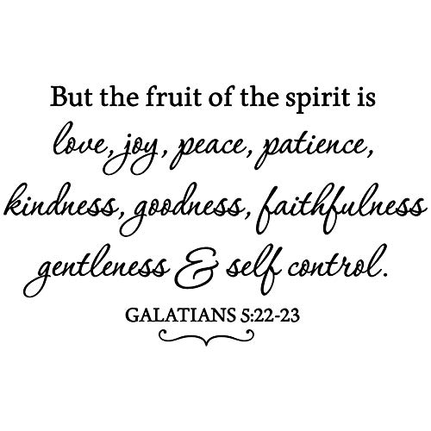  June 21, 2026  Brooklyn Community United Methodist Church  Pastor Jinkyoung You
Welcome to  Brooklyn Community United Methodist Church  June 21, 2026  Third Sunday after Pentecost  Minister: Pastor Jinkyoung You  Reader: Roxanne Thompson  Pianist: Debbie Schneider  Percussionist: Dennis Murphy  Welcome & Greeting  Birthday, Anniversary, & Announcements  Prelude  Call To Worship: (Congregation reads the bold)  With all your strength, sing aloud to the Lord, who has brought you here and blessed you.  Our voices shall shout forth praise and thanksgiving to God.  With all your heart, reach out in service to those in need, remembering God's mercy in your own life.  Our lives shall be witnesses to the love of God which has been lavished upon us.  Come, let us worship the Lord with Great joy!  Let us bring all that we have and all that we are to God in gratitude. AMEN.  Opening Prayer  *Hymn of Praise UMH #122  “God of the Sparrow, God of the Whale”  Joys and Concerns |  |  | Father’s Day Litany:  We thank God for fathers and fatherly figures.  We give thanks for their love, guidance, sacrifice, and care.  We pray for fathers who are joyful, tired, grieving, learning, or trying again.  May God give them strength, wisdom, patience, and grace.  We remember those for whom this day is tender or difficult.  May God bring comfort, healing, and peace.  All: Loving God, help us reflect your faithful love in our families, our church, and our world. Amen.  Pastoral Prayer/The Lord’s Prayer  *Hymn of Response UMH #114  “Many Gifts, One Spirit”  Scripture Reading Philippians 4: 1-9 (CEB)  Congregation Response: Thanks be to God.  “Prayer” Sheila Olsen  Message “Fruit of the Spirit: Joy” Pastor Jinkyoung  *Offering/Doxology UMH #95  *Hymn of Affirmation “Give Thanks” TFWS #2036  Benediction  Postlude  *Stand if you are able.  Please join us for refreshments in our fellowship hall after the service.  UMH United Methodist Hymnal  CEB Common English Bible

