Upcoming Events:  June 18: Breakfast at Farm 42 at 9:00  June 25: Community Potluck at noon; bring a dish to pass, table service and beverage provided  June 29: Game Day at 1:00  Birthday: “God Bless You and Keep You Another Year Through”  Becky Tourdot June 15  If you wish to donate to the church, we now have the collection plate on the table by the entrance to the League Room. Or you can use our on-line giving option found on our website.  Contact Information:  Pastor Jinkyoung You  Office Hours: Tuesday 9:00 a.m. – 2:00 p.m.  Thursday 1:30 – 4:00 p.m.  Email: holistic78@gmail.com  Phone number: 608-455-3344 M-Th 9-4. If you need to reach her at other times, please use her private number 256-631-9906. Texting is best if possible.  Email: brooklyncommunityumc@gmail.com  Facebook: Brooklyn Community UMC  Website: http://www.brooklynumc.org/ |  |  | 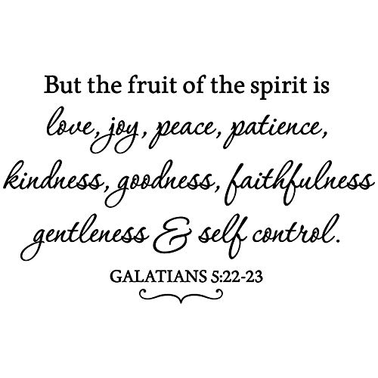  June 14, 2026  Brooklyn Community United Methodist Church  Pastor Jinkyoung You
Welcome to  Brooklyn Community United Methodist Church  June 14, 2026  Third Sunday after Pentecost  Minister: Pastor Jinkyoung You  Reader: Sheila Olsen  Pianist: Debbie Schneider  Percussionist: Dennis Murphy  Welcome & Greeting  Birthday, Anniversary, & Announcements  Prelude  Call To Worship: (Congregation reads the bold)  People of God, Jesus chooses us and calls us friends!  We abide in Christ because Christ abides in us.  Jesus made a home among us to show us the way of love.  We abide in Love because Love abides in us.  Jesus invites us to love one another as God has loved us,  and the Spirit grows this love within our hearts.  We abide in the Spirit because the Spirit bears fruit in us.  People of God, Jesus welcomes us into the life of God!  We come to make our home with God and one another, rooted in Christ, shaped by love, and renewed by the Spirit. Amen.  Opening Prayer |  |  | *Hymn of Praise UMH #463  “Lord Speak to Me”  Joys and Concerns  Pastoral Prayer/The Lord’s Prayer  *Hymn of Response UMH #715  “Rejoice, the Lord Is King”  Scripture Reading John 15: 9-17 (CEB)  Congregation Response: Thanks be to God.  “We Shall Behold Him” Performed by David Phelps  Requested by Russ Elmer  Message “Fruit of the Spirit: Love” Pastor Jinkyoung  *Offering/Doxology UMH #95  *Hymn of Affirmation “The Gift of Love” UMH #408  Benediction  Postlude  *Stand if you are able.  Please join us for refreshments in our fellowship hall after the service.  UMH United Methodist Hymnal  CEB Common English Bible

