Upcoming Events:  June 2: No Methodist Circle meeting  June 4: Ice Cream Social and Brooklyn Dairy Queen Crowning; 4:30-7:30; Crowning at 7:00.  June 4-7: Pastor Jinkyoung will be at the Wisconsin Annual Conference. Jim Brown is our lay leader to annual conference this year.  Birthday: “God Bless You and Keep You Another Year Through”  Jessica Hawkey June 2  Jerry Johnson June 4  Kyle Smith June 5  Anniversaries:  Kendall and Debbie Schneider May 31  Kyle Smith and Jessica Hawkey June 4  Please join us for refreshments in our fellowship hall after the service.  If you wish to donate to the church, we now have the collection plate on the table by the entrance to the League Room. Or you can use our on-line giving option found on our website.  Contact Information:  Pastor Jinkyoung You  Office Hours: Tuesday 9:00 a.m. – 2:00 p.m.  Thursday 1:30 – 4:00 p.m.  Email: holistic78@gmail.com  Phone number: 608-455-3344 M-Th 9-4. If you need to reach her at other times, please use her private number 256-631-9906. Texting is best if possible.  Email: brooklyncommunityumc@gmail.com  Facebook: Brooklyn Community UMC  Website: http://www.brooklynumc.org/ |  |  | 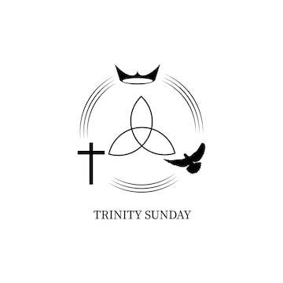  May 31, 2026  Brooklyn Community United Methodist Church  Pastor Jinkyoung You
Welcome to  Brooklyn Community United Methodist Church  May 31, 2026  Trinity Sunday  Minister: Pastor Jinkyoung You  Reader: Jo-Ann Draheim  Pianist: Joanie Heinze  Percussionist: Dennis Murphy  Welcome & Greeting  Birthday, Anniversary, & Announcements  Prelude  Call To Worship: (Congregation reads the bold)  On this Trinity Sunday, we come to praise the Triune God - Father, Son, and Holy Spirit!  We praise God who creates, redeems, and sustains all creation!  We come to wade into the depths of the divine mystery of God, the One-in-Three and Three-in-One.  We seek an ever-deepening faith in God who creates, redeems, and sustains all creation!  We come to witness the interconnectedness of the Triune God, to marvel at the divine dance of partnership and cooperation.  We receive the invitation to join the divine dance of God who creates, redeems, and sustains all creation!  Come, let us worship the Triune God - Father, Son, and Holy Spirit!  Come, let us worship the Triune God who creates, redeems, and sustains all creation! |  |  | Opening Prayer  *Hymn of Praise UMH #175  “Jesus, the Very Thought of Thee”  Joys and Concerns  Pastoral Prayer/The Lord’s Prayer  “One” Written by Dennis Murphy  *Hymn of Response Verses 1-4 UMH #192  “There’s a Spirit in the Air”  Scripture Reading Matthew 28: 16-20  2 Corinthians 13: 11-13 (CEB)  Congregation Response: Thanks be to God.  “I Need Thee Every Hour” Sheila Olsen and Joanie Heinze  Message Pastor Jinkyoung  “Trinity: Love All the People”  *Offering/Doxology UMH #95  *Hymn of Affirmation “Spirit of God” Vs. 1, 3, 5 TFWS #2117  *Benediction  Postlude  *Stand if you are able.  UMH United Methodist Hymnal  TFWS The Faith We Sing  CEB Common English Bible

