Upcoming Events:  April 6-April 13: Pastor Jinkyoung is on vacation.  April 7: No Circle meeting  Birthday: “God Bless You and Keep You Another Year Through”  Esther Hong April 6  If you wish to donate to the church, we now have the collection plate on the table by the entrance to the League Room. Or you can use our on-line giving option found on our website.  Contact Information:  Pastor Jinkyoung You  Office Hours: Tuesday 9:00 a.m. – 2:00 p.m.  Thursday 1:30 – 4:00 p.m.  Email: holistic78@gmail.com  Phone number: 608-455-3344 M-Th 9-4. If you need to reach her at other times, please use her private number 256-631-9906. Texting is best if possible.  Email: brooklyncommunityumc@gmail.com  Facebook: Brooklyn Community UMC  Website: http://www.brooklynumc.org/ |  |  | 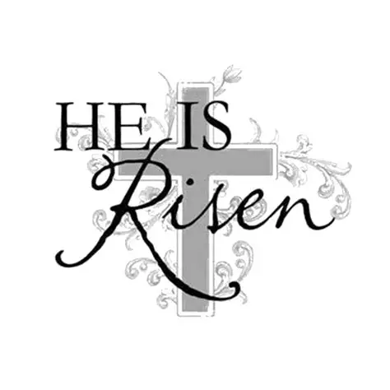  April 5, 2026  Brooklyn Community United Methodist Church  Pastor Jinkyoung You
Welcome to  Brooklyn Community United Methodist Church  April 5, 2026  Easter Sunday  Minister: Pastor Jinkyoung You  Reader: Julie Anderson  Pianist: Debbie Schneider  Percussionist: Dennis Murphy  Prelude  Welcome  Call To Worship: (Congregation reads the bold)  Easter people, we gather today as people who spent the week inundated with news reports, social media posts, and reels that inundated us with information, worry, and stress.  Like the disciples on the road to Emmaus, we carry the weight of being overwhelmed and anxious, wondering who we can believe.  We gather as people who long for peace, for God to break through and bring us clarity and hope once again.  Like the disciples on the road to Emmaus, we don’t always recognize when the Risen One comes alongside us, showing us the way where there seems to be no way.  We gather as people hoping to catch a glimmer of Resurrection, ready for our hearts to burn with the truth of the resurrected Christ.  Like the disciples on the road to Emmaus, we open our hearts to the possibility that God’s Resurrection life is closer than we think.  Easter people, God knows the burdens we carry, and God is faithful to meet us where we are with good news.  May the good news of the Resurrection astound us today as we come to worship God! Amen. |  |  | Opening Prayer  *Hymn of Praise Verses 1-4 UMH #302  “Christ the Lord Is Risen Today”  “The First Time I Ever Saw His Face” Dennis Murphy  Scripture Reading Luke 24: 13-35 (CEB)  Congregation Response: Thanks be to God.  “Up from the Grave” UMH #322  Spirit of the Moment Choir  Message Pastor Jinkyoung  “Meeting the Risen Christ on the Road”  *Offering/Doxology UMH #95  “On the Wings of a Dove” Jim, Ginny, Andy, Shahla, Mason  Holy Communion  *Hymn of Affirmation “He Lives” UMH #310  *Benediction  Postlude  *Stand if you are able.  Please join us for Easter breakfast in our fellowship hall after the service.  UMH United Methodist Hymnal  CEB Common English Bible

