Upcoming Events:  April 24: Community Potluck noon; bring a dish to pass, table service and beverage provided.  April 26: Coffee and Conversation 9-11  May 4: Church Time changes to 10:30 a.m.  Birthday: “God Bless You and Keep You Another Year Through”  Merrilee Blackmer April 23  Walker Shedivy April 24  If you wish to donate to the church, we now have the collection plate on the table by the entrance to the League Room. Or you can use our on-line giving option found on our website.  Pastor Jinkyoung You  Office Hours: Monday, Tuesday and Thursday 1-3:30 p.m.  Days off: Friday and Saturday  Email: holistic78@gmail.com  Phone number: 608-455-3344 M-Th 9-4. If you need to reach her at other times, please use her private number 1-256-631-9906. Texting is best if possible.  Email: brooklyncommunityumc@gmail.com  Facebook: Brooklyn Community UMC  Website: http://www.brooklynumc.org/ |  |  | 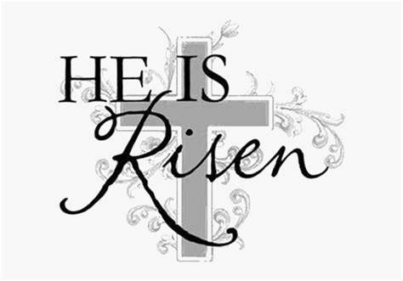  April 20, 2025  Brooklyn Community United Methodist Church  Pastor Jinkyoung You
Welcome to  Brooklyn Community United Methodist Church  April 20, 2025  Easter Sunrise Service  Minister: Pastor Jinkyoung You  Reader: Julie Anderson  Pianist: Debbie Schneider  Percussionist: Dennis Murphy  Welcome & Greetings  Birthdays, Anniversaries & Announcements  Prelude  CALL TO WORSHIP (Congregation reads the bold)  This is the day that the Lord has made.  Let us rejoice and be glad in it!  This is the day of resurrection.  Let us rejoice and celebrate!  This is Easter Sunday.  Alleluia! Alleluia!  Opening Prayer  *Hymn of Praise Verses 1-4 UMH #302  “Christ the Lord Is Risen Today”  Joys and Concerns  Pastoral Prayer |  |  | *Hymn of Response UMH #304  “Easter People, Raise Your Voices”  “Easter Hallelujah” Cassandra Star and Callahan  Scripture Readings John 20: 1-18 CEB)  Congregation Response: Thanks be to God.  “O Happy Day” Dennis Murphy  Message Pastor Jinkyoung  “The Story Is Not Over”  *Offering/Doxology UMH #95  Holy Communion  *Hymn of Affirmation “He Lives” UMH #310  Benediction  Postlude  *Stand if you are able.  Please join us for refreshments in our fellowship hall after the service.  UMH United Methodist Hymnal

