Upcoming Events:  April 15: Bible Study at 1:00 a.m.  April 17: Newsletter item due.  April 20: Conversation and coffee at church 9-11.  Birthdays: “God Bless You and Keep You Another Year Through”  Elissa Rezabek April 14  Jeremiah Tilley April 19  If you wish to make an offering to the church, we now have the collection plate on the table by the entrance to the League Room. You can also give on-line using the “Giving” tab on our church website: https://www.brooklynumc.org/  Contact Information:  Pastor Yaba Lucie Anongba  Office Hours: Mondays 9-2  Phone number: 608-455-3344  E-Mail: lucieyaba@yahoo.fr  brooklyncommunityumc@gmail.com  Facebook: Brooklyn Community UMC  Website: http://www.brooklynumc.org/ |  |  | 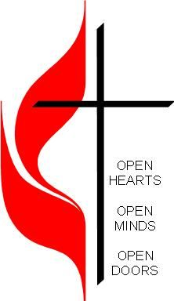  April 14, 2024  Brooklyn Community United Methodist Church  Pastor Yaba Lucie Anongba
Welcome to  Brooklyn Community United Methodist Church  April 14, 2024  Third Sunday of Easter  Minister: Pastor Yaba Lucie Anongba  Pianist: Debbie Schneider  Readers: Pat Wilkening  Percussionist: Dennis Murphy  Prelude  Welcome  *”His Name Is Wonderful” 2 Times #174  Opening Prayer  Call to Worship (congregation reads the bold)  Shout for joy to the Lord, all the earth, worship the Lord with gladness.  Come before him with joyful songs, know that the Lord is God.  It is God who made us, and we are his, we are his people, the sheep of his pasture.  Enter his gates with thanksgiving and his courts with praise.  Give thanks to him and praise his name.  For the Lord is good and his love endures forever; his faithfulness continues through all generations.  ”Holy God, We Praise Thy Name” Verses 1, 2, 4 #79  *Passing of the Peace |  |  | Announcements, Joys, and Concerns  Prayer Time/The Lord’s Prayer  *”There Is Something About That Name” 2 Times #171  Children’s Message  “Counting My Blessings” performed by Seph Schlueter  Scripture Reading Acts 16:22-36  Congregational Response: “Thanks be to God.”  Message Pastor Yaba  “Power of Praise”  *Offering/Doxology #95  *”Come, Thou Almighty King” Verses 1, 2, 3 #61  Benediction  Postlude  *Stand if able  Do all the good you can,  by all the means you can,  in all the ways you can,  in all the places you can,  at all the times you can,  to all the people you can,  as long as ever you can.  John Wesley

